**SQL Exercise 1**

1. Create the table SEMP with the following structure:-

EMPNO CHAR(4)

EMPNAME CHAR(20)

BASIC FLOAT

DEPTNO CHAR(2)

DEPTHEAD CHAR(4)

mysql> create table SEMP(

-> EMPNO CHAR(4),

-> EMPNAME CHAR(20),

-> BASIC FLOAT,

-> DEPTNO CHAR(2),

-> DEPTHEAD CHAR(4));

Query OK, 0 rows affected (0.02 sec)

1. Create the table SDEPT with the following structure:-

DEPTNO CHAR(2)

DEPTNAME CHAR(15)

mysql> create table SDEPT(

-> DEPTNO CHAR(2),

-> DEPTNAME CHAR(15));

Query OK, 0 rows affected (0.03 sec)

1. Insert into the SDEPT table the following values:-

10, Development 20, Training

mysql> insert into SDEPT(DEPTNO,DEPTNAME)

-> values(10, 'Development'),

-> (20, 'Training');

Query OK, 2 rows affected (0.01 sec)

Records: 2 Duplicates: 0 Warnings: 0

1. Insert into the SEMP table the following values:-

0001, SUNIL, 6000, 10

0002, HIREN, 8000, 20

0003, ALI, 4000, 10, 0001

0004, GEORGE, 6000, 0002

mysql> insert into SEMP(EMPNO,EMPNAME,BASIC,DEPTNO, DEPTHEAD)

-> values(0001, 'SUNIL', 6000, 10,null),

-> (0002, 'HIREN', 8000, 20,null),

-> (0003, 'ALI', 4000, 10, 0001),

-> (0004, 'GEORGE', 6000,null, 0002);

Query OK, 4 rows affected (0.01 sec)

Records: 4 Duplicates: 0 Warnings: 0

**Create S, P, J, SPJ tables as specified below and insert a few rows in each table:-**

**SUPPLIER - S**

(S#, Sname, Status, City) –

mysql> create table SUPPLIER(

-> S_number char(4),

-> Sname varchar(20),

-> Status int (4),

-> City varchar (10));

Query OK, 0 rows affected, 1 warning (0.03 sec)

mysql> insert into SUPPLIER(S_number ,Sname ,Status ,City )

-> values('S1','Supplier A',10,'London'),

-> ('S2','Supplier B',20,'Paris'),

-> ('S3','Supplier C',30,'Athens'),

-> ('S4','Supplier D',15,'Berlin'),

-> ('S5','Supplier E',25,'Madrid'),

-> ('S6','Supplier F',35,'Rome'),

-> ('S7','Supplier G',40,'Lisbon'),

-> ('S8','Supplier H', 22,'Amsterdam'),

-> ('S9','Supplier I',28,'Brussels'),

-> ('S10','Supplier J',12,'Vienna');

Query OK, 10 rows affected (0.03 sec)

Records: 10 Duplicates: 0 Warnings: 0

**PARTS -P**

(P#, Pname, Color, Weight, City) –

mysql> create table PARTS(

-> P_number char(4),

-> Pname varchar(20),

-> Color varchar(20),

-> Weight varchar(20),

-> City varchar(10));

Query OK, 0 rows affected (0.03 sec)

**PROJECTS – J**

(J#, Jname, City)

mysql> create table PROJECTS(

-> J_number char(4),

-> Jname varchar(20),

-> City varchar(10));

Query OK, 0 rows affected (0.03 sec)

**SUPPLIER-PARTS-PROJECT - SPJ**

(S#, P#, J#, Status)

mysql> create table SUPPLIER_PARTS_PROJECT(

-> S_number char(4),

-> P_number char(4),

-> J_number char(4),

-> Status int(4));

Query OK, 0 rows affected, 1 warning (0.05 sec)

Sample data for S# column:- ‘S1’, ‘S2’, ‘S3’, etc.

Sample data for P# column:- ‘P1’, ‘P2’, ‘P3’, etc.

Sample data for J# column:- ‘J1’, ‘J2’, ‘J3’, etc.

Sample data for Status column:- 10, 20, 30, etc.

mysql> insert into SUPPLIER_PARTS_PROJECT( S_number, P_number,J_number, Status)

-> values('S1','P1','J1',10),

-> ('S2','P2','J2',20),

-> ('S3','P3','J3',30),

-> ('S4','P4','J4',40),

-> ('S5','P5','J5',50),

-> ('S6','P6','J6',60),

-> ('S7','P7','J7',70),

-> ('S8','P8','J8',80),

-> ('S9','P9','J9',90),

-> ('S10','P10','J10',100);

Query OK, 10 rows affected (0.01 sec)

Records: 10 Duplicates: 0 Warnings: 0

**Write the SELECT queries to do the following:-**

1. **Display all the data from the S table.**

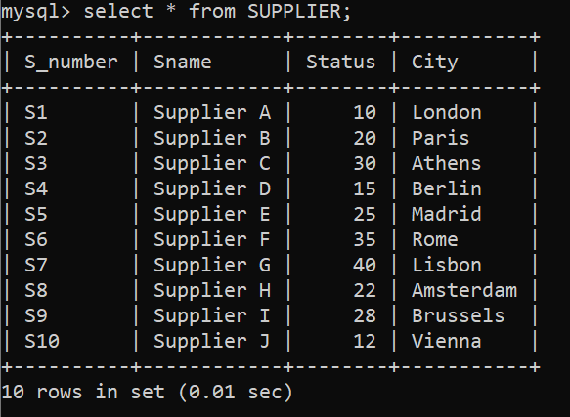

1. **Display only the S# and SNAME fields from the S table.**

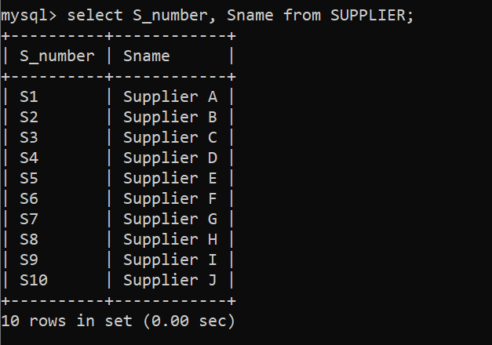

1. **Display the PNAME and COLOR from the P table for the CITY=”London”.**

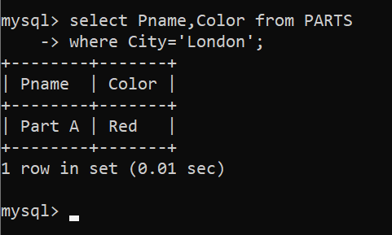

1. **Display all the Suppliers from London.**

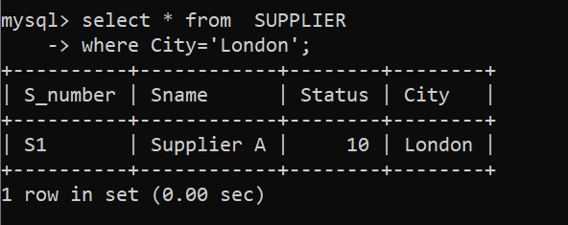

1. **Display all the Suppliers from Paris or Athens.**

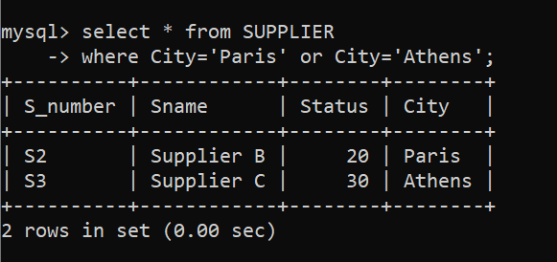

1. **Display all the Projects in Athens.**

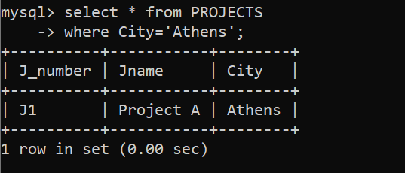

1. **Display all the Partnames with the weight between 12 and 14 (inclusive of both).**

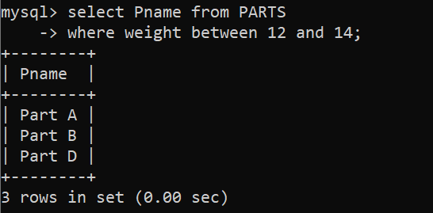

1. **Display all the Suppliers with a Status greater than or equal to 20.**

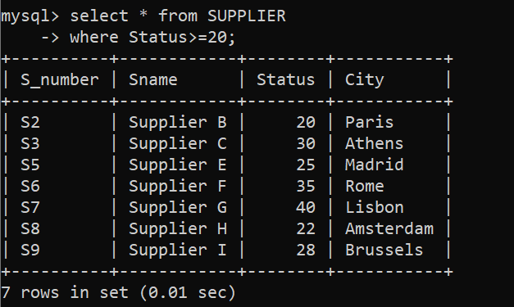

1. **Display all the Suppliers except the Suppliers from London.**

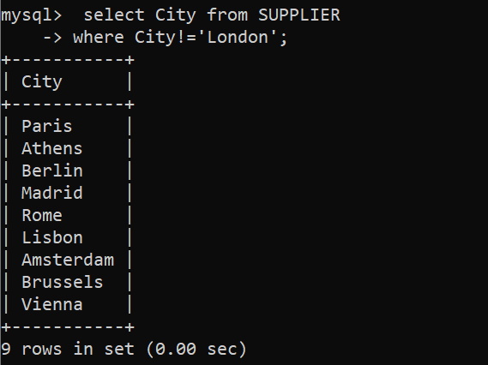

1. **Display only the Cities from where the Suppliers come from**

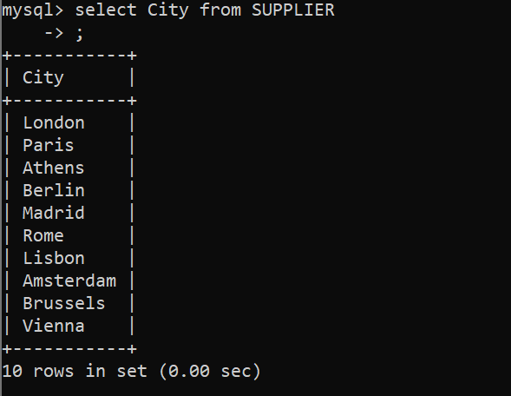

1. **Assuming that the Part Weight is in GRAMS, display the same in MILLIGRAMS and KILOGRAMS.**

